**Summary**

**Aim:** Proposing an EOG free data driven approach for removal of ocular artefact using 10-layer CNN architecture

There is a significant overlap in muscular artefact and neuronal data. INFOMAX is used for ICA implementation. 20 ICA components were realised.

**Dataset:**

**Imaging Telemetry And Kinematic modeLing in youth football dataset.**

44 high school subjects underwent MEG study for 8 mins. The signal is down-sampled to 250 Hz with a notch-filter at 60 Hz and then a bandpass filter from 1Hz and 100 Hz. 14 subjects were chosen for training and 30 for test.

In training randomly 1 subject is chosen for cross validation and trained on 13 subjects. Brainstorm[1] toolbox is utilised to produce topographic maps.

**Architecture:**

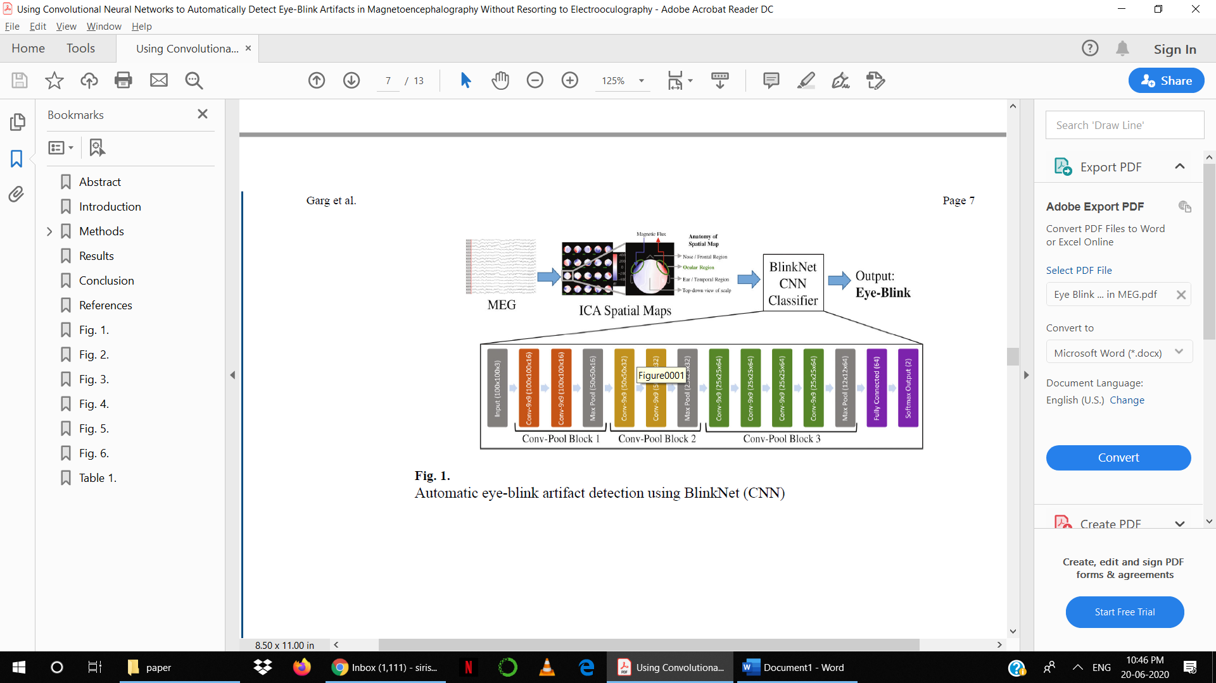

* Dropout of 0.5 for 1st Fully Connected layer
* Batch Normalisation
* Batch size = 16
* Learning rate = 1e-5
* Reduce by factor of 10 for 4 epochs
* Total epochs = 40

**Saliency Maps and grad-CAM**

In order to explain the interpretability of the NN models, the saliency maps and grad-CAMs are constructed.

The saliency maps highlight the input regions which have largest influence on the SoftMax output.

This can be calculated by measuring the gradient of the output with respect to individual pixels.

Grad-CAM visualises feature maps by computing the gradient of the feature map from the last convolutional layer for a given image. Unlike saliency maps, the feature region is associated to a class which has strongest reliance.

1. Tadel F, Baillet S, Mosher JC, et al.: Brainstorm: a user-friendly application for MEG/EEG analysis. Comput. Intell. Neurosci 2011, 879716 (2011). doi:10.1155/2011/879716 [PubMed: 21584256]